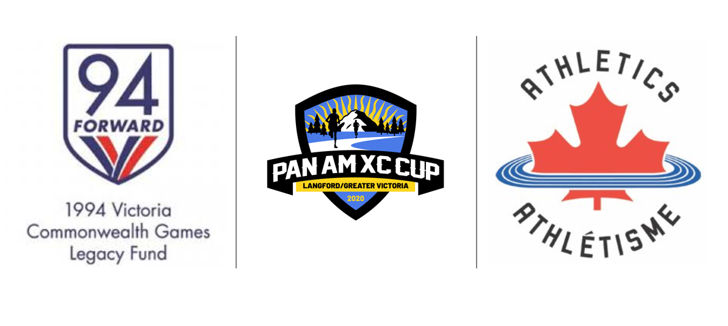
Pan Am Cross Country Running Championships
On February 29th, 2020 Victoria’s Bear Mountain will host the prestigious Pan American Cross Country Running Championship. This event will feature some of the world’s finest distance runners and Team Canada is ready to go! Quebec athlete Genevieve Lalonde leads an outstanding women’s team that will race over the 10km course.
“I'm very excited to be representing the Canadian team once again. I think this is a great opportunity for the team to test their skills on Canadian soil. IGenevieve Lalonde – Canadian Cross Country Champion
Kids Can Run Too!!
The organising committee of the Pan Am Cross Country are very pleased to invite all school children from Kindergarten to grade 8 to participate in a 1.6km race. These runners can register as either an individual or be a member of their school team. Each school that registers can select a Pan American Country to “adopt” for the championship race. We are calling this kids race “The Nations Cup”. Visit the following link to learn more about this exciting event: www.Panamxccup2020.com/events/nations-cup/

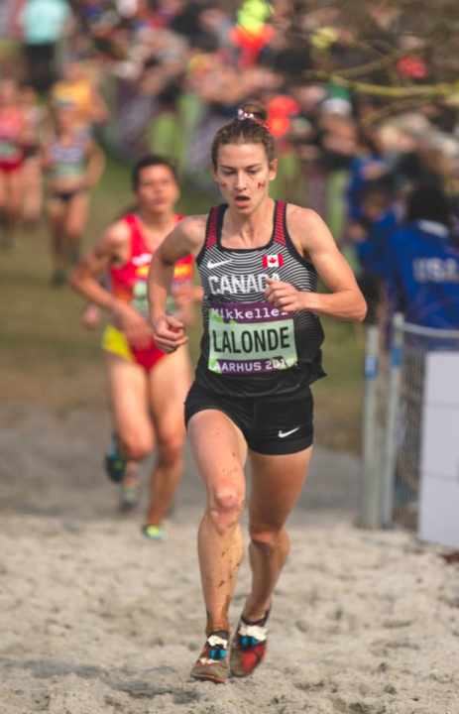

To register your child visit:
https://www.trackie.com/online-registration/register/nations-cup-xc/37050/

